# How to access your flash drive and personal files from <http://remote.msjc.edu>:

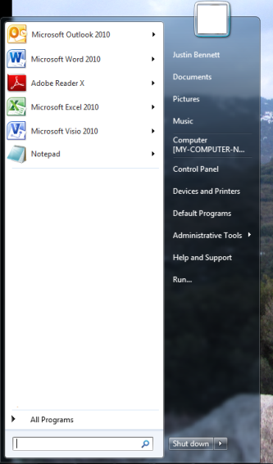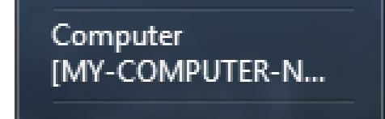

**Opening files from a flash drive within a Remote Desktop Session**:

1. Open the “Computer” link on your laptop / desktop

1. Make note of what drive letter your Flash Drive  
   is using. For example, My Drive Letter is E:

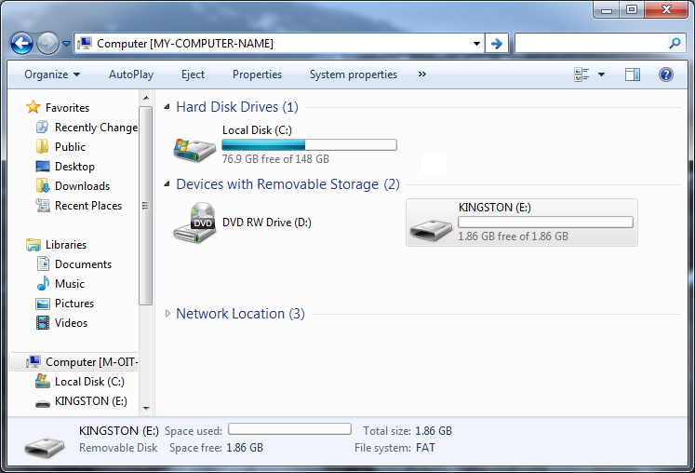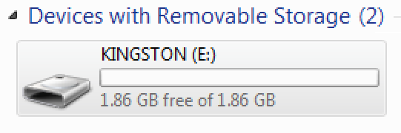

1. Connect to <http://remote.msjc.edu>. See the  
   [*Connecting to Remote Desktop Services*](https://www.msjc.edu/IT/Pages/Tutorials.aspx)   
   tutorial.



IMPORTANT: Check the box for “*Drives*”  
to enable accessibility of your Flash Drive.

1. From within your Remote Desktop Session,  
   Open the “Computer” link

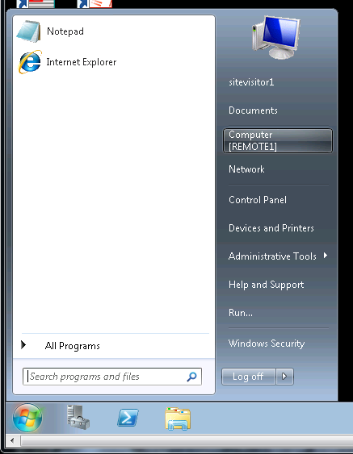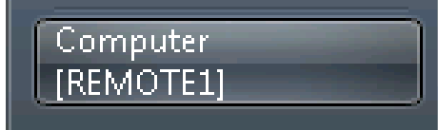

1. Within Remote Desktop Services, navigate to the Flash Drive drive letter (using drive letter noted on step #2) on your “Computer”.

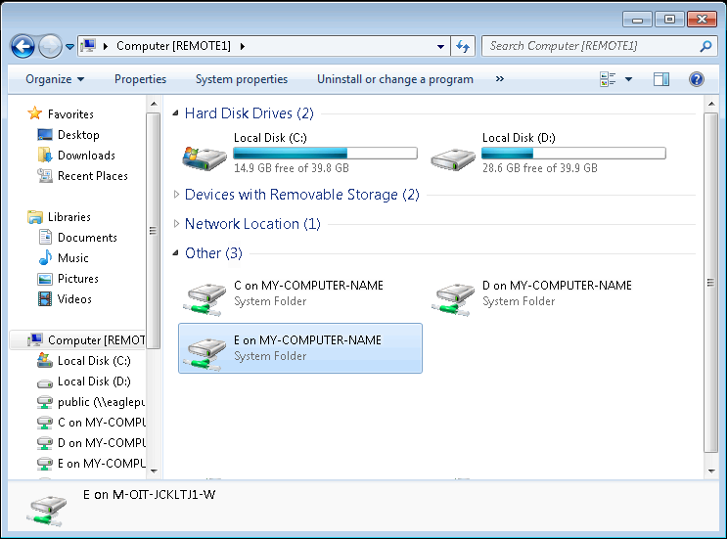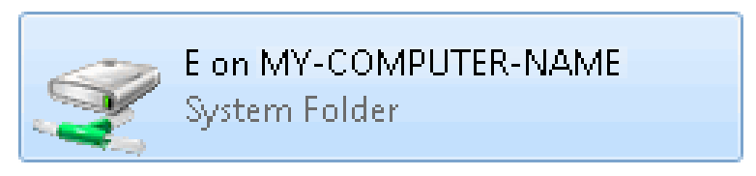

For example, my flash drive letter is

“E on MY-COMPUTER-NAME”.

1. 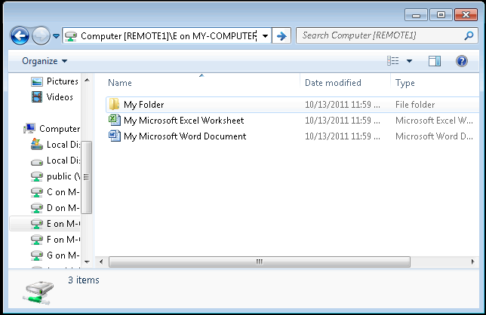You should now be able to view/add/remove

files located your flash drive via

<http://remote.msjc.edu>. You can access

these files from within other applications

located within the Remote Desktop

Services; such as Word, Excel, etc…