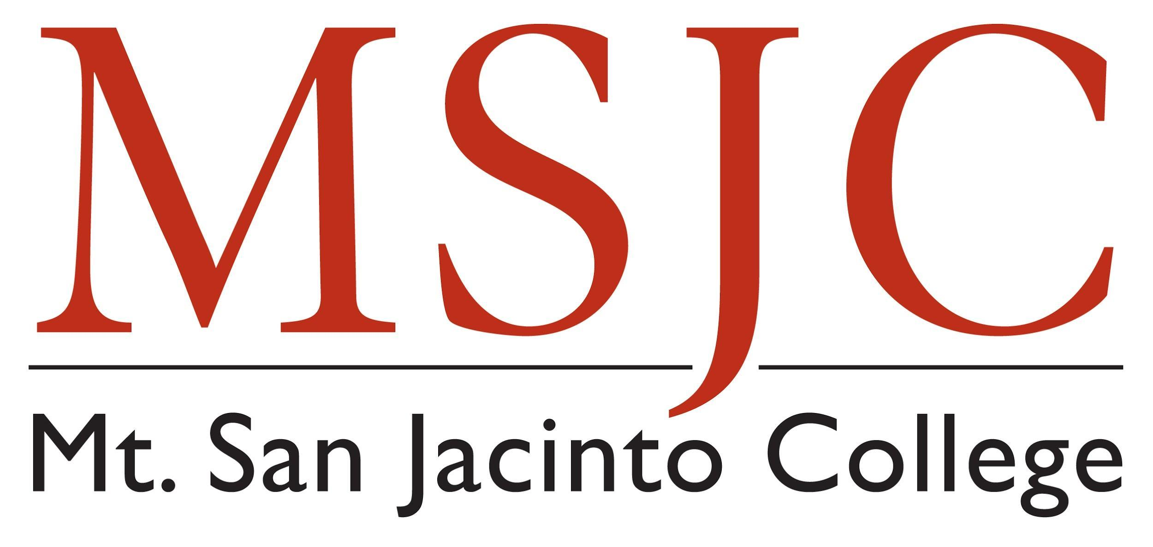
[Physical Geography]

[Fall 2018 SJC]

[GEOG101, Section 3805]

Course Information

Course Description
[Insert Course Description here: Access description by searching your Course in Curricunet]

Course Objectives
Upon completion of this course you will be able to do the following:
- [Insert Course Objectives here: Access Course Objectives by searching your Course in Curricunet]

Course Learning Outcomes (CLOs)
- [Insert CLOs here:]

Online ANYTIME Course
[Insert information here: Review MSJC’s information about Real-Time/Anytime courses. Example: This course is an Online ANYTIME course which means there are no required on campus or virtual meetings. All of the course work is available on your own time, 24/7 via Canvas. Interaction with me and other students will take place through discussion boards, group assignments, and messages in Canvas. I will offer optional Zoom sessions, but there are no required real-time meetings.]

Instructor Information
Instructor: [Dr. Marlon Brando]
[OPTIONAL: You can include a brief bio, personal statement, or your teaching philosophy here if you wish to provide additional information. You can optionally provide this information in other places of the course.]
- Email: [mbrando@msjc.edu]
- Phone: [OPTIONAL]
- Office: <Room 908 at the San Jacinto Campus (SJC)>
- Office Hours: <Monday online 2:00-4:00pm & Wednesday on campus 3:00-5:00pm>
- Zoom Link for Online Office Hours: https://cccconfer.zoom.us/j/123456789

Course Materials

Required Text
[Insert text information here]
You can purchase this textbook from the MSJC Bookstore on MBS Direct.

Required Software/Resources
[Insert software or online resources (optional & required) information here – examples below]
- Internet Access
  - This course is fully online, so appropriate Internet access is required. Computer devices used to access this course should have audio and video streaming capability. This includes desktops, laptops, tablets and smartphones.
- Canvas
  - Canvas is the online virtual classroom for this course section. Through Canvas, registered students have access to all course resources. All course work must be submitted directly through Canvas. Instructions on how to submit your work will be provided in Canvas.
  - Google Chrome is the recommended browser for Canvas. There is also a Canvas Student App available for both iOS & android devices from either the App Store or Google Play.
- Additional Free Technology
  - In addition, you will need the following software to read course documents and complete assignments:
    - Adobe Reader is free software to view PDFs
    - Microsoft Office 365 is provided by MSJC for all enrolled students. Login using your MSJC student email credentials.
    - MSJC Remote Desktop Service provides access to the SPSS software you will need for this course [include if you use RDS software].
- Additional Paid Technology
  - This course requires the use of online content to complete required activities.
    - [Insert access and/or purchase information here]

Grading Policy
[Update or delete tables as needed]
Your grade for this course will be computed based on points awarded for various types of activities. This course is worth 1000 points. Please note that points displaying in Canvas may be based on graded assignments only, not total available points for the course. Learn more about how grades display in the canvas gradebook to ensure you have an accurate measure of your progress throughout the course.

Coursework Breakdown
Assignments Types | Total Points
Assignments | 300
Discussion Participation | 200
Unit Quizzes | 100
Midterm Exam | 100
Final Exam | 100
Project | 200
All Assignments | 1000

Grade Scale
Letter Grade | Percentage % | Points
A | 90-100% | 900-1000
B | 80-89% | 800-899
C | 70-79% | 700-799
D | 60-69% | 600-699
F | 0-59% | 0-599

Late Submissions and Make-up Work
[Insert information here. For example: All due dates are provided in Canvas directly in each activity, in the Calendar, and in the Syllabus Course Summary. Course work submitted on time will receive instructor feedback within 2 weeks.
Course work may be submitted after the due date, but may not receive instructor feedback on the same schedule as work submitted on time. If you need an extension on any course work, please contact me in advance to discuss an adequate extension timeline. It is important to stay current with the course activities, and if you are focusing on catching up this may impact your future participation. I want to help you be successful and reach to course objectives, so the sooner you communicate with me the quicker I can provide assistance.]

Class Participation/Dropping the Course
[Example: It is important that you participate regularly in the class activities; however, if you determine that you can no longer participate you can drop or withdraw from the course. It is ultimately your responsibility to drop the class, so you should monitor your grade and the college drop deadlines. If I notice that you are not participating (such as not submitting any assignments for a given week, or not participating in two consecutive discussion activities) I will contact you to see if there is anything I can do to help you get back on track. If I don’t hear from you, I may drop you from the course for lack of participation.

Course and College Policies

Online Communication/Regular Effective Contact
[Insert information here. Example:
What communication and interaction in this course looks like:

My goal is for this to be an interactive class which means that you can expect to regularly interact with me and with each other. Just like an in-person class, we all benefit from your voice and presence in the class. I am here to help through email or Canvas message and you can expect a response within 24-72 hours. Additionally, I have designed ways to help you work with and stay in contact with me and your peers, such as:

- Discussion Boards: EXPLAIN WHAT THIS LOOKS LIKE IN YOUR CLASS; describe what the faculty to students & students to students interactions will look like including frequency, expectations, absences (can or cannot participate in discussion activities after the due date)
- Announcements: EXPLAIN WHAT THIS LOOKS LIKE IN YOUR CLASS
- Grading/Feedback: EXPLAIN WHAT THIS LOOKS LIKE IN YOUR CLASS
- Email/Canvas Message: EXPLAIN WHAT THIS LOOKS LIKE IN YOUR CLASS; example: The best method for communicating with me is through the Canvas Inbox. You can expect a response from me within 24-48 hours, except for holidays and weekends.

**We recommend breaking down each type of communication/interaction with a description specific to your course.]

Online Course Etiquette / Technology Use
[Insert information here. Consider including information like the Core Rules of Netiquette infographic. And reminding students that they are required to comply with the MSJC Acceptable Use Policy when using MSJC Information and Communications Technology (including Canvas).

Equity, Diversity, and Inclusion
[Insert Information here, Example: Mt. San Jacinto College is committed to supporting the diversity of its students and communities and as such, this virtual classroom will be a space committed to anti-racism, anti-sexism, and anti-homophobia. I believe it is important that our class is a space where we can work to understand ourselves and others better. To do this, we must have respect for each other and treat each other with dignity, which requires that we value and affirm each other’s experiences.
We, the Mt. San Jacinto College Faculty, Classified Professionals, and Administrators, acknowledge there are systemic barriers that have historically excluded and prevented equal outcomes for students on the basis of:
- Race/ethnicity
- Gender Identity and Expression
- Sexuality
- National Origin
- Socioeconomic status
- (Dis)Ability
- Language
- Religion
- Age
- Physical Appearance
- Intersections of these identities.

Therefore, we define equity as an investment and commitment to achieving parity in academic outcomes by removing institutional barriers and creating an inclusive and culturally affirming learning environment. As such, we are dedicated to challenging our perceptions, biases, and blind spots through self-reflection and constant inquiry to identify and eliminate equity gaps and reinvest in our communities.
Our purpose is to celebrate diversity, instill hope, and empower our students to transform their lives and those around them.]

Academic Integrity and Honesty
[Insert information here. Example: As an academic institution, we see great value in your ideas, words, and work. To maintain academic integrity, do your best to do your own work and give credit to others where necessary. Cheating or plagiarism are taken very seriously and can result in disciplinary measures, such as no credit on the assignment or formal student conduct processes. Plagiarism occurs when you use someone else’s ideas, words, or work as your own, or when you submit work for credit that has already been submitted for credit elsewhere. If you have any questions or unsure how to acknowledge a source or if an action is okay, please talk to me or visit the Learning Resource Center.]

We are here to help you succeed! (Academic Support)
MSJC has many tools and services to help you be successful in your courses, and most can be accessed through the MSJC Student Support Hub.
- We have free tutoring and workshops available through the Learning Resources Centers or Career and Technical Education Tutoring Centers, as well as access to technology and research assistance in our campus libraries.
- Some classes offer additional support through SI (Supplemental Instruction) and embedded tutoring.
- Additionally, there are several programs and resource centers aimed at helping students get extra support like EOPS, CalWORKs, the Career and Transfer Center, the Eagle Access Center, the Veteran’s Resource Center, and the Honors Program.
We also offer support for students with diverse abilities and needs through the Accommodation Service Center (ASC, formerly Disabled Student Programs and Services) because Mt. San Jacinto College values students regardless of ability and abides by the American with Disabilities Act and Section 504 of the Rehabilitation Act of 1973 that prohibits federal and state agencies or programs from discriminating against qualified individuals with disabilities. The Learning Skills Program offers individualized support for students with learning disabilities.
And, we understand that our students have needs beyond the classroom. We have Health Centers at both campuses, including Mental Health Services, a childcare center at the San Jacinto campus, as well as support for students who are experiencing housing, food, or financial insecurity.
For more information and details on any of these services, please visit MSJC.EDU/HUB

Course Schedule
[The course schedule should include applicable dates/times for each class session or for each module/unit, and due dates/times for major assignments, readings, and exams. Adjust the table as needed]
Week/dates | Reading/Topics | Assignments/Exams | Points Possible
1 (8/12/19-8/18/19)
2 (8/19/19-8/25/19)
...

